**ReadMe file - Reddit Top Articles API**

**Introduction:** This API allows users to retrieve the top articles from a subreddit. The returned data is sanitized to provide only useful and meaningful information. The API simplifies the process of fetching and filtering articles, providing users with a streamlined and efficient way to access the most relevant content from their favorite subreddits.

**running the program:**

* Make sure you installed Python
* For installing relevant libraries: pip install -r requirements.txt
* you can send HTTP requests to the API using their preferred method, including tools like curl, Postman, or even web browsers
* You can run the program via your terminal using the command: "uvicorn fastAPI:app –reload"
* Or you can choose to run it via your favorite IDE and debug it if you wish. Please note, in this case the local server address is as it is written inside the main: host="0.0.0.0", port=7000

**Parameters:**

|  |  |  |
| --- | --- | --- |
| Parameter | Type | Description |
| subreddit | string | (Required) The name of the subreddit to retrieve articles from. |
| limit | integer | (Optional) The number of articles to retrieve. Default is 10. Must be positive integer. |
| timeframe | string | (Optional) The timeframe to consider for top articles. Options: hour, day, week, month, year, all. Default is month. |

**Example request:**

<http://'LocalServer'/reddit?subreddit=python&limit=10&timeframe=all>

**Error Responses:**

The API returns the following error responses in case of any issues:

1. 404 Not Found: Returned when the requested subreddit is not found on Reddit.
2. 500 Internal Server Error: Returned when there is an error retrieving data from the Reddit API.
3. 503 Service Unavailable: Returned when the Reddit API is temporarily unavailable.
4. 403 Access Forbidden: Returned when access to the Reddit API is forbidden.
5. 422 Unprocessable Entity: Returned when the request is well-formed but contains invalid data.

**Suggested test cases:**

1. Test retrieving top articles from a specific subreddit: Provide a valid parameter as requested and verify that the API returns a response with status code 200 and the expected article data.

It is recommended to run the test few times with the same parameters in order to check the consistency of the system.

Example:

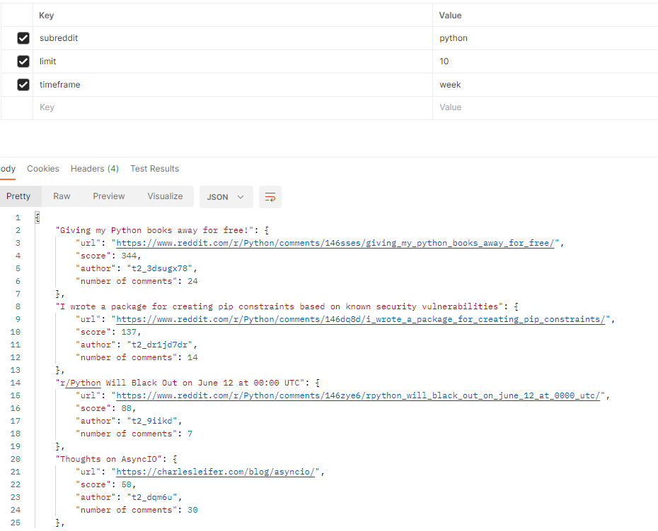

1. Ask for non-existing data and verify that the API returns a response with status code 404 as excepted.

Example:

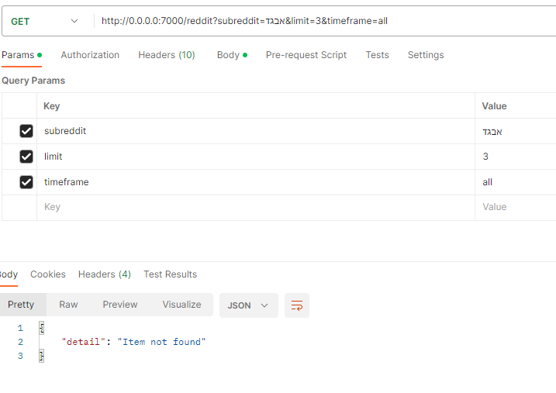

1. Try to insert invalid parameters, for example invalid limit (<=0) or invalid timeframe and verify that the program changes it to the default value.

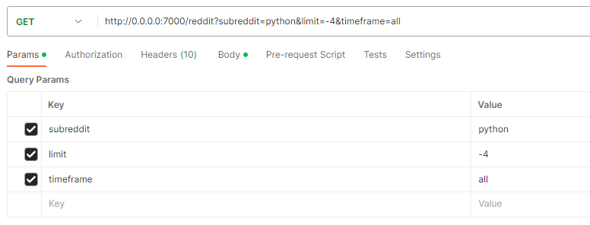Example of invalid parameters – negative integer as a limit:

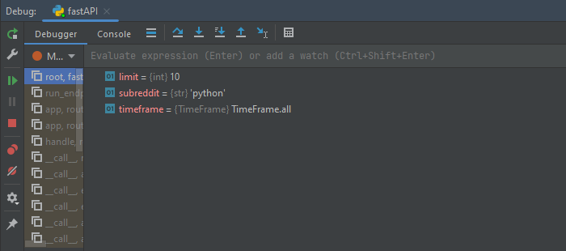

**deployed application link:** https://reddit_api-1-k0439153.deta.app/